Ecological stressors within the River Shannon Catchment

Samuel Dornan

20385853

[samuel.dornan@ucdconnect.ie](mailto:samuel.dornan@ucdconnect.ie)

# **1 Introduction**

Climate change and other human activities have resulted in significant environmental changes across the globe, and Ireland is no exception. In this paper I will attempt to uncover some of the more significant concerns that may be present in Ireland, focusing in particular on the River Shannon Catchment as it is the largest such catchment in Ireland.

To do this, I will use a corpus of text from the Clarivate Web of Science database, an online database of peer-reviewed articles and papers from a wide variety of publications, which gives users the ability to filter their searches with filters such as the number of citations, region of interest, and publication date among other factors. As well as this, users have the ability to bulk-download article metadata including titles, abstracts, authors, and so forth.

**1.1. Literature Review**

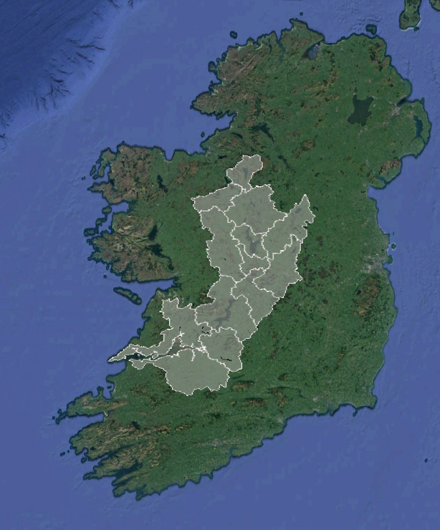

*(Map of drainage embankments built within the River Shannon Catchment; Dornan, Mooney & O’Keeffe, 2022)*

The Shannon Catchment has been the subject of significant drainage and development works since the early 20th century, which have had a corresponding effect on the ecology of the region. Specifically there have been changes in the migratory patterns of local fish such as brown trout, Atlantic salmon, and silver eel among others.

The current ability of most computer programmes to infer relationships between topics is limited, in spite of much fanfare to the contrary (citation needed), however it is adequate in order to gain a broader understanding of the catchment and any ongoing issues related to it. Specifically, we can use versions of T5 fine-tuned for question answering to gain a broad understanding of the key topics related to the area, including problem areas and major research themes

**Method**

**References**